

* Acquire and maintain the ability to deliver on all courses across the Academy.
* Coaching students and imparting information and instructions clearly and concisely in both group and one-to-one settings.
* Provide support to the WM’s to ensure all training is compliant with national guidance / legislation / best practice and / or awarding body requirements
* Implement effective training and development activities.
* Be highly motivated, self-driven and able to work with minimal supervision.
* Have a strong awareness and understanding of and a personal commitment to health and safety.
* Be willing to work flexibly to meet the commitments of the Training Academy.
* Perform other duties appropriate to the post and within the context of the National Occupational Standard Role Map for a Crew Manager.

You will take a delivery role principally on all Breathing Apparatus courses within the Academy, including supporting Maritime delivery. Where required there will be the need to support training delivery at Severn Park and other locations across the Service. The role will require you to develop and maintain, through continuous professional development (CPD), your ability to deliver. You will be expected to contribute toward the content of training policies and implementation plans, supporting your WM’s to ensure training packages are up to date and National Operational Guidance compliant. You will need to communicate effectively with people at all levels, both orally and in writing, including preparing reports and evaluations, giving presentations and leading training sessions.

You will be an integral part of a team that supports the development of staff to meet our service delivery needs.

You will work collaboratively with colleagues within the Academy and other specialist staff, as necessary, to ensure all DSFRS training needs and standards are met, whilst conforming to health & safety, equality & diversity and demonstrating our core values.

The Service aim to ensure that all staff feel valued, supported, safe and well trained to deliver a high performing fire and rescue service.

The primary role of the Training Academy is to ensure that Service staff are highly trained and have the skills and knowledge to reduce the risks in our communities and respond safely and effectively to emergencies.

* Respect for all
* Guiding others
* Leading by example
* Including everyone
* Creating an environment where everyone feels safe to learn.

Working as a team we prioritise our work considering risk, resource and our current four strategic priorities, as detailed in the Academy Plan and Service Delivery strategy.

**Training Delivery Instructor**

**(Crew Manager)**

One pager

Scop and design ICT platform for NOG product response priorities. We will implement National Operational Guidance, legislative requirements and organisational priorities, as defined in the Service Delivery Strategic Plan along with priorities set by the Resilience Department Plan.









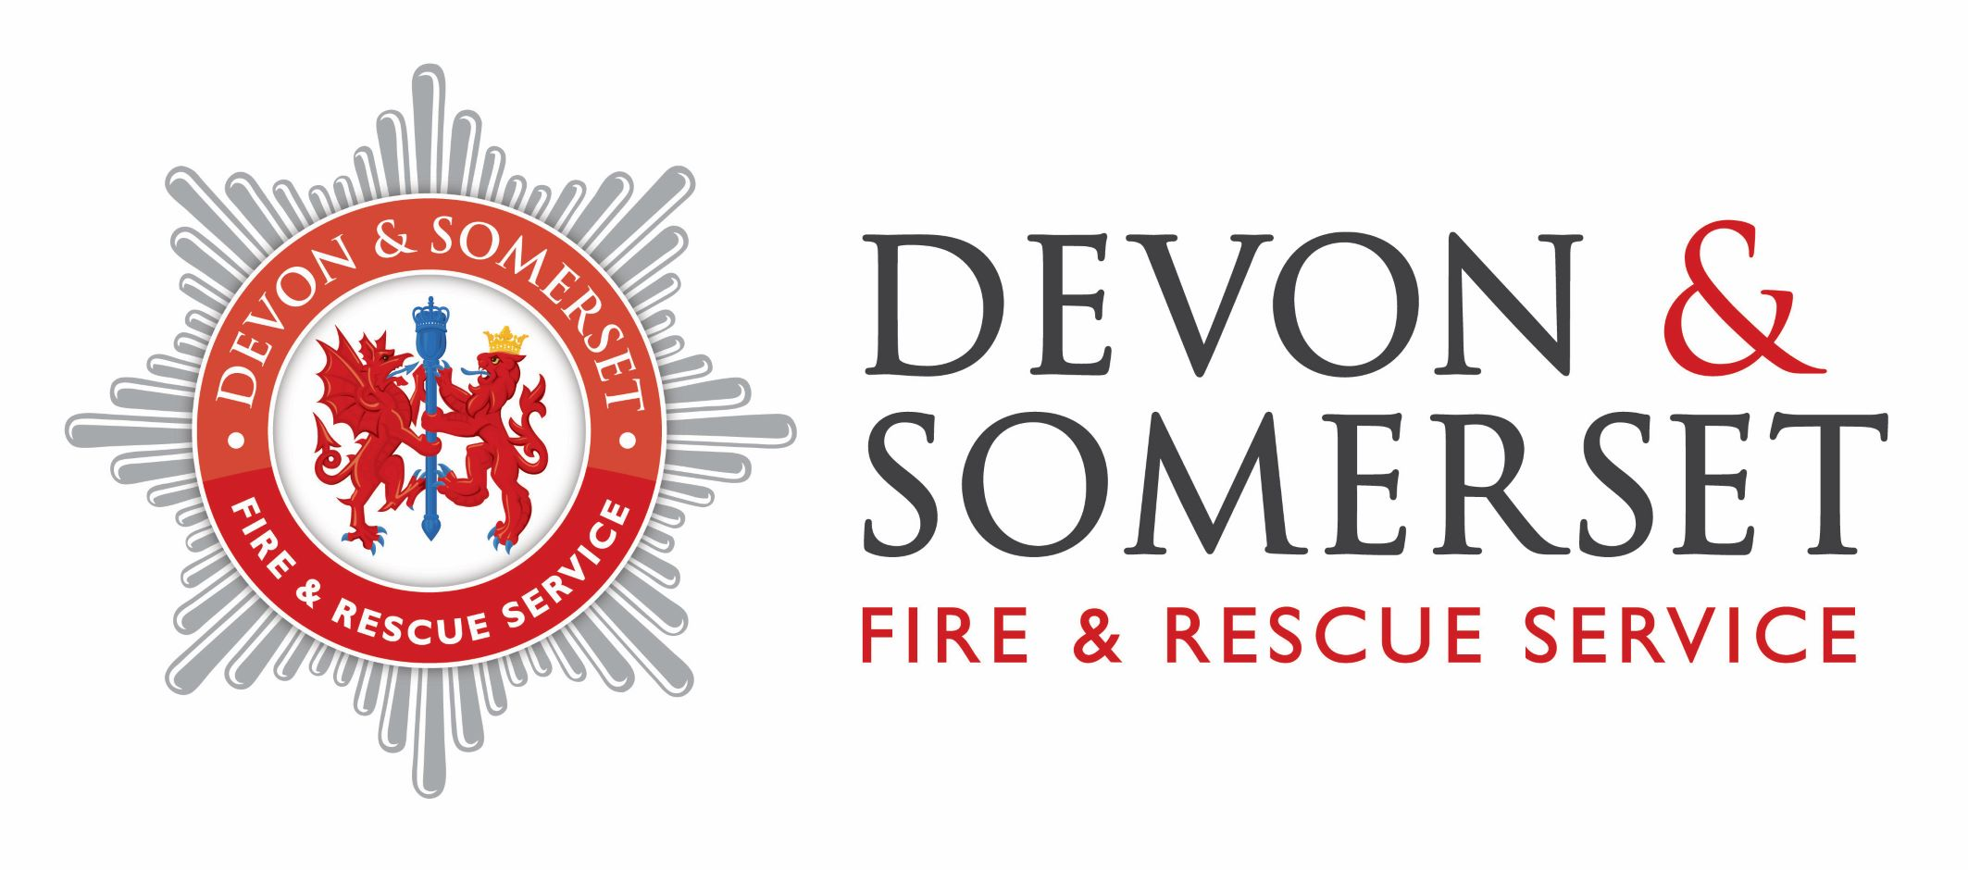

Permanent



