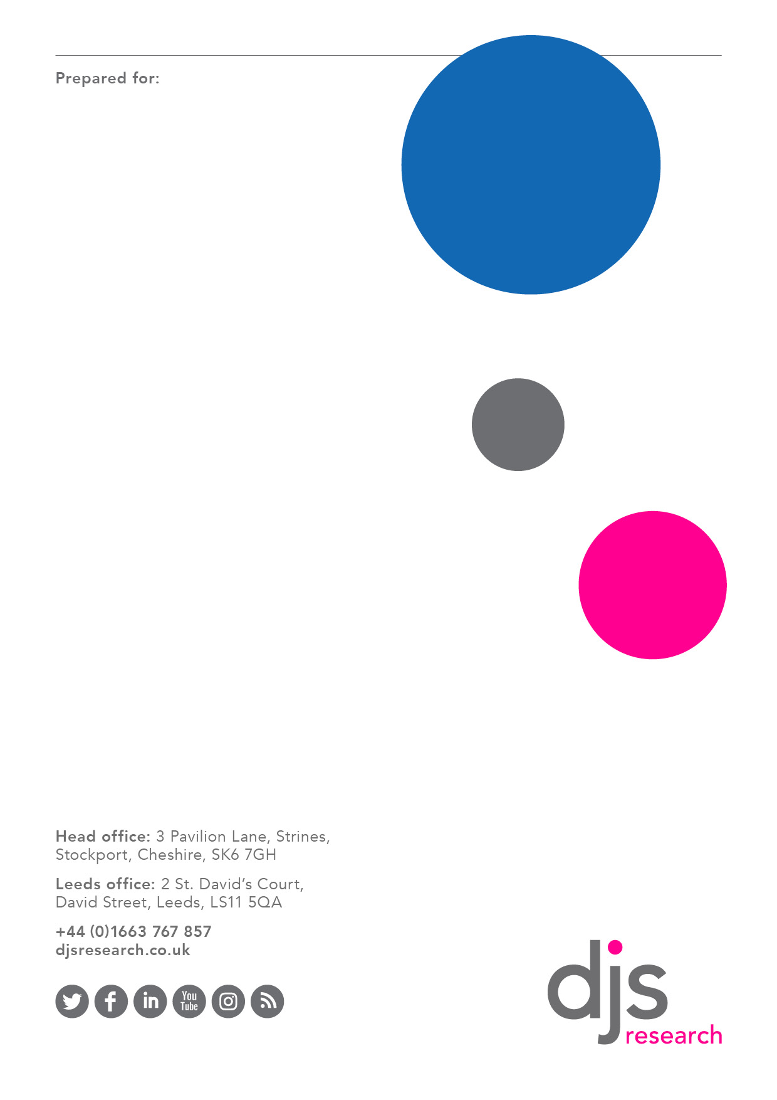
cvzx
Community Risk Management Plan:
Quantitative Research Report


June 2021
Elliot Simmonds, Research Director
esimmonds@djsresearch.com
Grace Middlehurst, Senior Research Executive
gmiddlehurst@djsresearch.com

Contents

Contents
Introduction 3
1.1 Context 3
1.2 Methodology 4
Profile of responses 7
2.1 Relationship to DSFRS 7
2.2 Demographics 7
2.3 Spread of responses across service area 15
Engagement findings 17
3.1 The role of the fire and rescue service 17
3.2 Importance of specific duties 19
3.3 Additional duties or considerations 24
3.4 Perception of risk and relative likelihood to occur 25
3.5 Anxiety in relation to risks 27
Modelling likelihood and anxiety 31
3.6 Reducing risk anxiety 33
3.7 Risk in the local community 36
3.8 Interacting with the fire and rescue service 40
3.9 Looking to the future 44
3.10 General comments 49
Appendix I: Participating Councils 53
Appendix II: Participating Partners 55
Appendix III: 56

Introduction

1.1 Context

Devon and Somerset Fire and Rescue Service (hereafter DSFRS) is the largest non-metropolitan fire and rescue service in England. They provide prevention, protection and response services across the counties of Devon and Somerset (including Torbay and Plymouth). When considering the profile of participants, it should be noted that not all of Somerset sits within DSFRS’ service are. Neither of the larger urban areas of Bath and Weston-super-Mare are within the service area for instance. A map of the service area is included below for reference.

DSFRS have 84 fire stations and over 1,800 staff who work to protect the 1.7 million people who live in Devon, Somerset, Torbay and Plymouth, alongside the estimated extra 400,000 people who visit this part of the country every year.

Map 1: DSFRS service area and assets
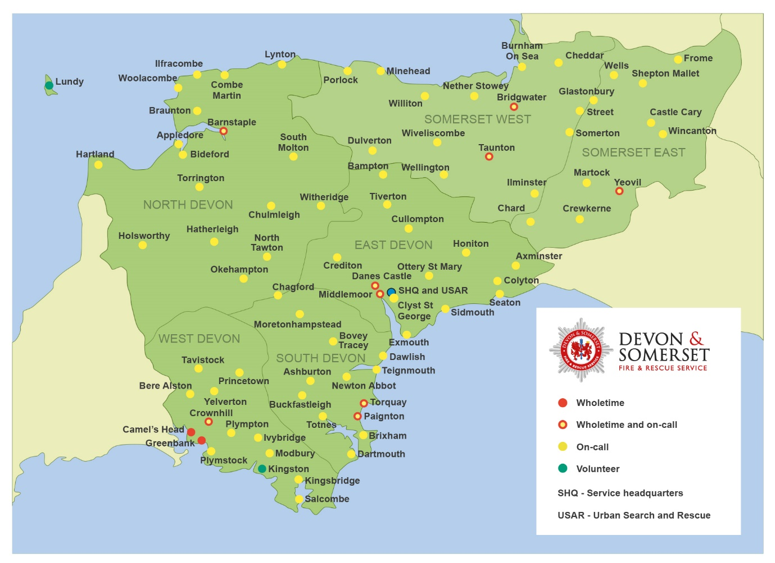

In April 2021, DSFRS commissioned DJS Research Ltd (DJS) to support an engagement process which will feed in to a new Community Risk Management Plan (CRMP). From April 2022 the CRMP will replace the two previous plans - Integrated Risk Management Plan (IRMP) and Fire and Rescue Plan - combining elements of them both. It will run until 2027.

DJS provided support in three core ways:

- Management and delivery of a qualitative online community with a selection of key audiences which DSFRS had identified a requirement to hear from in-depth
- Analysis of quantitative data generated by a survey designed, delivered and hosted by DSFRS
- Provision of telephone surveys to ensure accessibility of the above survey to those who were unable or preferred not to complete the survey online – these were carried out by a team of specialist telephone interviewers.

This report deals specifically with the results of the second and third bullets above, the quantitative data. However, where relevant reference is made to the qualitative report.

This report, alongside the qualitative findings and other data (e.g., incident data) will be utilised by DSFRS to produce a CRMP document for review. A further consultation will then take place to ensure that the information provided by communities in Devon and Somerset has been accurately interpreted and are reflected in the document.

1.2 Methodology
To ensure that this engagement was open to as many Devon and Somerset residents as possible no quotas were set on participation and no upper limit to the number of completes was instituted.

The survey was open from 8 April – 20 May 2021 and garnered 1694 completes. This includes a number of participants who were supported to complete the engagement survey by telephone as well as those who completed online.

Due to on-going restrictions as a result of coronavirus (COVID-19) it was not possible to undertake face-to-face engagement events in a safe and practical way. Instead, the survey was hosted on the DSFRS website and utilised a responsive design to ensure accessibility on all devices (e.g. smartphones and tablets as well as laptop or desktop computers). In addition, a dedicated phone number for the engagement was shared through posters and press releases. The engagement itself was promoted via a range of channels by the DSFRS team, including:

- inclusion in the weekly internal newsletter
- social media posts
- inclusion on DS Connect (widely used by on-call staff)
- on the home page of DSFRS’ web page and intranet
- virtual staff sessions, recorded and shared with all staff
- station visits
- letters to key stakeholders including the Police and Crime Commissioner, clinical commissioning croups (CCGs), members of Parliament, police forces, county, district and parish councils, DSFRS partner organisations
- targeted Facebook advertising

There are several points of note in relation to this report specifically:

- The data which appears in this report has not been subject to weighting. This means that all participants who completed the survey are represented in an equally valid way within this report; although where relevant we have provided results broken down by key sub-groups of interest as requested by DSFRS. The qualitative report looks in further detail at a number of sub-groups.
- DSFRS were particularly interested in understanding the views of a number of specific audience groups. Respondents were asked whether they identified as being a member of or working with one or more of these groups and this question has been used for sub-group analysis throughout, where reference is made to ‘specific audience groups’. The makeup of these groups is outlined at Chart 8 (p.13).

- Throughout the report, where reference is made to one sub-group being ‘significantly more likely’ than another sub-group to act in a certain way or hold a specific opinion, this is a statistically significant difference at the 95% confidence level utilising chi-square testing. Although it should be noted that:

  - The data was gathered using an opportunity sample. It is therefore not possible to estimate sampling error or the extent to which the sample is representative of the whole population of 1.7m residents.

  - If the dataset had been gathered using a probability sample, we might estimate a confidence interval of +/-2.38% at a confidence level of 95%. In practice that would mean that a survey result of 50% could reflect a real population response of between 47.62% and 52.38%.

- It was decided that not all questions would be mandatory for completion by participants and thus throughout this report, bases for questions vary. This decision was taken by the DSFRS team in order to allow people to provide meaningful responses to questions which were relevant to them rather than forcing all respondents to complete all questions and risk respondent fatigue and reduced data quality.

- Throughout, where we refer to ‘Young People’ this is a self-identifying and group (17-25) specifically considered by DSFRS and reflects the terminology utilised in the survey. When we are making comparisons between age groups we utilise specific ages, for instance Under-35, 35-64, over-65 and over-75.

Profile of responses

2.1 Relationship to DSFRS
In total, n=1694 usable responses were received as part of the survey.
Of these, the majority were members of the public (69%). Around a quarter of respondents (23%) had a relationship with DSFRS; 15% were Operational staff, 6% were support staff and 2% were from a DSFRS partner. Throughout, where relevant, we have reported on four core audience groups: member of the public, Council representatives, business representatives and those with a relationship to DSFRS (support staff, operational staff and partners). Where differences exist between DSFRS staff we have outlined this, however.

Chart 1: Relationship to DSFRS

Q02. Are you answering as a…(Base: 1675)

2.2 Demographics
Three quarters of responses were from residents of Devon (74%) with the remainder being from Somerset (26%). More than half of respondents describe the area they live in as being rural (54%), around one in three said urban (28%) and a smaller proportion said coastal (15%). 2% described their local area in another way.
Respondents were typically older, reflecting the demography of the local area. Only around one in twelve respondents were aged under 35 (12%); with the majority being between 35 and 64 (63%). A quarter of respondents were 65 or older (23%) – with one in 20 being 75 or older (5%).
Younger respondents (those aged between 25 and 54) were more likely to have a relationship to DSFRS – either as support or operational staff, or as a partner.

Chart 2: Age profile of respondents

Q24. Which of the following age ranges do you fall into? (Base: Total: 1672, Relationship to DSFRS: 383, Member of the public: 1146)

Respondents were broadly evenly split in terms of their gender identity with 51% identifying as a woman and 45% identifying as a man. Around one in twenty said they preferred not to say (4%). The majority said that their gender matched their sex as registered at birth (95%) – with 4% again saying prefer not to say. In total, n=5 respondents (0.3%) stated that their gender identity did not match their sex as registered at birth.
To ensure services are developed in an inclusive way, DSFRS asked a question about participants’ sexuality. Just fewer than nine in ten said they were heterosexual (89%) with a further 7% saying that they preferred not to say. Around 5% of participants described themselves as being either gay, bi-sexual or preferring to self-describe.

Chart 3: Sexuality of participants

Q27. Which of the following best describes how you think about yourself? (Base: 1653)

Participants were provided with a definition of disability as defined in the Equality Act 2010:
The Equality Act 2010 defines someone as a disabled person if they have a physical or mental impairment which has long term and substantial adverse effect on their ability to carry out normal day to day activities. Such examples may include; HIV, cancer, mobility, sight or hearing impairments or depression.

When answering this question you should not take into account the effect of any medication, treatment or adaptions which reduce the effects of impairment. You should think about the effect your impairments have if medication or treatments were not being used or made.
Based on the above definition, 10% of participants said that they did consider themselves to be disabled (85% did not, 5% preferred not to say).
As the age of participants increased, their propensity to define themselves as disabled increased – with around a quarter of those aged 75 or older saying that they considered themselves to have a disability (23%).
Chart 4: Participant disability

Q28. In relation to the definition of disability above, do you consider yourself to be disabled? (Base: Total 1658; 75+: 88; 65+: 380; 35-64: 1036; under-35: 204)

Three fifths of participants had no caring responsibility (59%) and 6% said that they preferred not to say. The remainder was made up of a combination of those responsible for caring for children and those caring for other adults.
Chart 5: Caring responsibility of participants

Q29. Do you have any caring responsibilities? (Base: 1634)
Half of participants said they identified as holding a Christian faith (50%), with the next largest group saying they had no religion (40%). Almost one in ten said they prefer not to say (8%) and a handful said ‘Other’ (2%). As age increased among participants, we see a rise in the proportion identifying as Christian and a reduction in the number identifying as having no religion – this trend is reversed for younger audiences.

Chart 6: Participant religion

Q30. What is your religion? (Base: 1664)

The majority of participants identified as being from a white ethnic group (93%). One in 20 said they would prefer not to say (5%), 1% identified as being from a mixed ethnic background (n=14) and fewer than 1% of respondents identified as being from black or black British backgrounds (n=4) or Asian or Asian British backgrounds (n=2). 1% said they were from an Other ethnic background (n=14).
In total, excluding prefer not to say, n=34 participants selected an ethnic minority background in total (2%).

Chart 7: Ethnic background

Q31. How would you describe your ethnic group? (Base: 1666)

Participants were asked if they identified as belonging to one of a number groups which DSFRS are particularly keen to hear from. Almost one in five participants in total said they were a member of one of these groups (17%) and 83% said they were not.
Those that identified as one of these groups were then asked which of the groups they identified with – they were able to select more than one group and thus percentages do not sum to 100% in the chart below.
Those in the youngest and oldest age groups were the most likely to identify themselves as being in one of these groups. Almost three in ten of those under-35 (29%) and more than a third of those aged over 75 (36%) identified in this way. Women (21%) and participants from ethnic minority backgrounds (32%) were also more likely to identify as being within one of these groups.

Chart 8: Membership of specific audience groups

Q14. Do you identify as a member of one of these groups? & Q15. Please indicate which group(s) you identify with… (Base: 1666)

Participants were also asked if their work (voluntary or paid) involved working with or supporting any of the specific audience groups. Just over a quarter (28%) said they did. Given the number of participants who work with multiple specific audiences it seems reasonable to suggest that many of them are undertaking formal volunteering or professional work with these audiences as opposed to caring – and this is supported by the earlier figures around caring responsibilities.

Chart 8a: Working with specific audience groups

Q16. Does your work (voluntary or paid) involve working with or supporting any of these groups? & Q17. Please indicate which group(s) you work with… (Base: 1662)

2.3 Spread of responses across service area
Devon and Somerset Fire and Rescue Service are keen to engage with communities from across the organisation’s service area. As a result, participants were asked to provide the first part of their postcode in order to allow for an analysis of the distribution of participants geographically.
The maps below outline DSFRS’ service area, overlaid with responses from the general public and DSFRS operational and support staff.

Map 2: General public responses
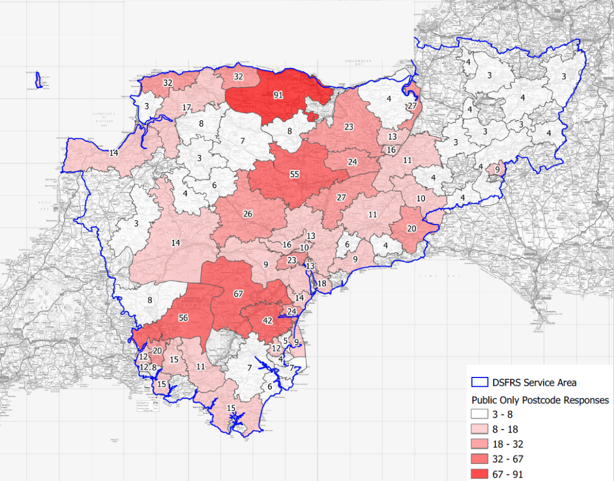
Map 3: DSFRS staff responses

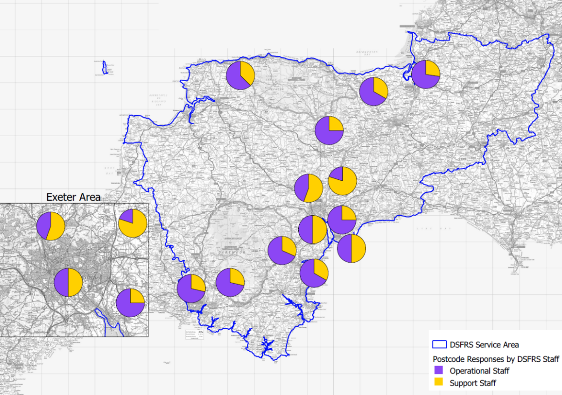

Engagement findings

3.1 The role of the fire and rescue service
Participants were asked what they thought the role of their local fire and rescue service was. Overall, the vast majority were aware of the full range of responsibilities undertaken by the fire and rescue service although ‘obtaining information from landlords and building owners to improve response’ and ‘ensuring those responsible for public and commercial buildings comply with fire safety regulations’ both garnered a lower response.

This was driven to a degree by low awareness among the general public, but is particularly clear among business owners (although on a small base).

Chart 9: What do you think your local fire and rescue service does...

Q5. What do you think your local fire and rescue service does...(Base: 1682)

Among specific audiences, people with learning disabilities and those for whom English is a second language were significantly less likely to be aware of the Service’s responsibility around a number of areas (see Appendix III for detailed data by specific audience group).

3.2 Importance of specific duties
Participants were then shown a passage about the role of the fire and rescue service, as follows, and were asked to provide feedback on how important each element of the fire and rescue service’s role is:

Devon and Somerset Fire and Rescue Service has a duty to:
Prevent fires and death or injury by fire through the provision of fire safety information and advice to our communities and enforcing relevant legislation in places where people work and visit. Provide a safe and effective operational response to meet a wide range of incidents. We undertake a wide range of statutory and non-statutory duties. Please indicate how important each of these duties are to you.

Chart 10: Please indicate how important each of these duties are to you....

Q6. Please indicate how important each of these duties are to you...(Base varies across attributes: 1654-1669). Note, the labels for ‘Very Unimportant’ and ‘Don’t Know’ have been removed for legibility. ‘Very important’ is 2% for animal rescue and 1% or below for all other duties. ‘Don’t know’ is 1% for working with local partners, and <1% for all others. The green figures to the right all refer to ‘Unimportant’ as per the chart legend.

Some groups were statistically more or less likely to see some duties as ‘very important’ and these are outlined below.

Responding to fires (96% ‘very important’ overall):
- Council representatives (92%)

Responding to road traffic collisions (89% ‘very important’ overall):
- DSFRS operational staff (96%)
- Council representatives (74%)
- Rural (86%) and Urban (91%) dwellers
- Those aged over 65 (86%) and over 75 (82%)
- Those from ethnic minority backgrounds (73%)

Responding to building collapse (78% ‘very important’ overall):
- Smokers (94%)
- Women (82%) and Men (74%)

Water rescue including flooding (74% ‘very important’ overall):
- DSFRS operational staff (84%)
- Council representatives (62%)
- People living alone (85%)
- Women (79%) and Men (70%)

Rescue from height or depth (73% ‘very important’ overall):
- DSFRS operational staff (82%)
- Council representatives (62%)
- Women (77%) and Men (70%)

Hazardous materials incidents and mass decontamination (74% ‘very important’ overall):
- People with learning disabilities (100%)
- People with mobility issues (84%)
- Under 35s (62%)
- Women (79%) and Men (69%)
- Those from ethnic minority backgrounds (59%)

Working with other Fire and Rescue Services across the country for large scale emergencies (locally and nationally) (66% ‘very important’ overall):
- People with learning difficulties (92%)
- 35-64s (68%)
- Women (72%) and Men (61%)

Working with our communities to help them understand how to keep safe and avoid an emergency situation (prevention) (56% ‘very important’ overall):
- DSFRS operational (70%) and support staff (71%)
- Members of the public (52%) and Council representatives (43%)
- People with learning disabilities (85%)
- People known to other agencies (100%)
- Smokers (74%)
- Families (71%)
- Those aged 65 or older (50%)
- Women (61%) and Men (52%)

Making sure that premises where people work and visit comply with fire safety legislation (protection) (60% ‘very important’ overall):
- DSFRS operational (71%) and support staff (77%)
- Members of the public (57%)
- People with mobility issues (71%)

Co-responding with the ambulance service (63% ‘very important’ overall):
- DSFRS operational staff (50%)
- Members of the public (68%)
- Rural (66%) and Urban (58%) dwellers
- People with learning disabilities (92%)
- People with poor mental health (81%)
- People living alone (78%)
- Young people (83%)
- Families (76%)
- Women (75%) and Men (53%)

Education at local schools (46% ‘very important’ overall):
- DSFRS operational (57%) and support staff (60%)
- Council representatives (26%)
- People with learning disabilities (85%)
- People with poor mental health (65%)
- Families (63%)
- Under 35s (54%)
- Those aged over 65 (41%) and over 75 (34%)
- Women (53%) and Men (41%)

Animal rescue (32% ‘very important’ overall):
- DSFRS operational staff (39%)
- Council representatives (17%)
- People living alone (44%)
- Young people (52%)
- Families (45%)
- Women (40%) and Men (23%)

Working with local partners, for instance gaining entry for the ambulance service (62% ‘very important’ overall):
- DSFRS support staff (51%)
- Members of the public (64%)
- People with mobility issues (74%)
- Smokers (81%)
- Women (71%) and Men (53%)

3.3 Additional duties or considerations
Participants were asked if there is anything else they would like to see DSFRS doing in their local community. This question was asked as an open response, meaning people could type as little or as much as they wished. Feedback was subsequently coded to draw out the key themes highlighted below.

Chart 11: Additional duties or considerations

Q7_. Is there anything else you would you would like to see Devon and Somerset Fire and Rescue Service doing in your local community? (Base: 345)

3.4 Perception of risk and relative likelihood to occur
Participants were asked about a number of risks and their likelihood to occur in their local area.
Chart 12: Perception of risk prevalence in local area

Q8. How likely are you to see these risks or hazards in your local area? (Base varies across attributes: 1628-1669; Other=581)

Those who identify as being a member of a specific audience group were significantly more likely to say several risks were ‘very likely’ in their area:
- Serious fires in commercial premises (25% vs. 16% doesn’t identify as specific audience group)
- Incidents as a result of decreased mental health or those with learning difficulties (27% vs. 20%)
- Incidents as a result of decreased physical health (25% vs. 18%)
- Pollution, including responding to hazardous materials (17% vs. 9%)
- Drowning and water safety (35% vs. 29%)
- Trapped persons (24% vs. 18%)
- Animal rescue (28% vs. 21%)
- Limited firefighter availability to respond to incidents (31% vs. 22%)
- Slow response time to incidents (25% vs. 19%)

Those who work with individuals in a specific audience group were significantly more likely to say several risks were ‘very likely’ in their area:
- Increasingly ageing population (59% vs. 48% doesn’t work with specific audience groups)
- Road traffic collisions (54% vs. 45%)
- Incidents as a result of decreased mental health or those with learning difficulties (31% vs. 17%)
- Incidents as a result of decreased physical health (24% vs. 18%)
- Drowning and water safety (36% vs. 27%)
- Animal rescue (25% vs. 21%)

Younger participants are more likely to cite incidents as a result of decreased mental health or those with learning difficulties as being very likely – 27% of under-35s and 24% of 35-64 year olds vs. 11% of over 65s and 13% of over 75s.
Those in rural (29%) and coastal (31%) regions are more likely to cite extreme weather, such as wide scale flooding, drought or snow as being ‘very likely’ compared to those in urban areas (16%).
Those in coastal areas are more likely to cite drowning and water safety (60%) as very important, as are people living alone (43%).
Those in urban areas are much less likely to cite wildfire (17%) than those in rural (35%) or coastal (33%) areas.
Those who identify as having a disability are much more likely to cite ‘trapped persons’ (27%) as very likely, as are families (28%) and people with poor mental health (38%).
Those in rural areas are more likely to cite ‘animal rescue’ (27%), as are people living alone (33%) and families (31%).
Those in rural areas are more likely to cite ‘limited firefighter availability’ as very likely (26%), those in urban areas are significantly less likely to see it as very likely (16%).
The elderly (85+) (41%), people with mobility issues (32%), people with poor mental health (43%), people known to other agencies (83%), people living alone (41%), those living in poverty (53%), and those identifying as substance abusers (67%) are all significantly more likely to say that ‘limited firefighter availability’ is very likely in their area.
Rural (22%) and coastal (25%) participants are more likely to cite ‘slow response times’ than those living in urban areas (13%).

3.5 Anxiety in relation to risks
All participants were asked if they personally felt at all anxious about any of the risks or hazards listed. At an overall level, a third of participants (34%) said that they felt some level of anxiety.
Those from ethnic minority backgrounds, those over the age of 75, those who identify as having a disability and those who identify as being members of a number of specific audience groups were more likely to say they were anxious about risks in their local community.
The general public were also significantly more likely to say that they were anxious compared to those with a relationship to DSFRS. Partners of DSFRS were significantly less likely to be anxious (less than one in 10 said they were at all anxious).

Chart 13: Anxiety by subgroup
Yes (overall sample)
Q9. Do you feel at all anxious about any of these risks or hazards? (Base: 1641 total; others vary by sub-group). The yellow line indicates the proportion of those saying that they had some level of anxiety across the overall sample. Darker bars that extend to the right of this line show where a specific sub-group over-index in terms of being anxious.

Those participants who said that they did have some anxiety about any hazards (n=555) were then asked the degree of anxiety they held about each of the previously displayed risks, as well as ‘other’ risks.

Chart 14: Anxiety about risks in local area

Q10. How anxious do you feel about these risks or hazards occurring in your local area? (Base varies across attributes: 539-550; Other=316)

Those who identify as being a member of a specific audience group were more likely to say they were completely anxious about the following risks:
- Dwelling fires (including thatch or high-rise buildings) (31% specific audience vs. 21% not identifying as a specific audience)
- Increasingly ageing population (25% vs. 14%)
- Serious fires in commercial premises (15% vs. 9%)
- Incidents as a result of decreased physical health (18% vs. 9%)
- Extreme weather, such as wide scale flooding, drought or snow (22% vs. 12%)
- Drowning and water safety (20% vs. 12%)
- Wildfire (22% vs. 14%)
- Trapped persons (15% vs. 9%)
- Animal rescue (11% vs. 5%)

Those who work with specific audience groups were more likely to say they were completely anxious about the following concerns:
- Incidents as a result of decreased mental health or those with learning difficulties (16% vs. 8% who do not work with specific audience groups)
- Civil unrest, including crime and terrorism (13% vs. 7%)

Other risks or hazards that were mentioned typically included references to concerns already covered including rural or isolated locations, narrow lanes or other issues limiting access by DSFRS appliances or other emergency service vehicles and perceived reductions in firefighter numbers as well as a number of unique responses considering large-scale socio-geopolitical issues or those very unique to individuals or their family:

My husband uses oxygen 24/7 so we have liquid O2 in the house.
New technology risks.
Climate Change in general.
Distance for emergency vehicles to travel along narrow roads insufficiently kept in good condition.
Reduction in local appliances and manpower.
Remote location on moorland and being able to access it due to terrain or adverse weather.
Are there resources available to respond to incidents safely & satisfactorily?

Modelling likelihood and anxiety
Utilising mean scores we can produce a matrix to understand the perceived likelihood and associated anxiety of participants in a more holistic way. Taking the chart below, we can see that there is a general correlation between the perceived likelihood of a particular risk actually occurring and the level of anxiety it creates among those who are anxious about it.

The mid-point of each axis is at the average of the mean scores for that measure (e.g. likelihood or anxiety). This allows us to consider, in relative terms, which risks are seen as most likely to occur relative to others, and which cause the most anxiety relative to the others.

The red quadrant outlines the risks which cause the highest levels of anxiety and are seen as most likely to occur – in particular road traffic collisions and dwelling fires. In contrast, civil unrest causes relatively little anxiety and is not seen as being particularly likely to occur.

Points J (Limited firefighter availability to respond to incidents) and M (Slow response time to incidents) provide the second and third highest levels of anxiety respectively – but are not seen as being particularly likely (or unlikely). Both of these issues are ‘perceptions’ rather than ‘events’ – and thus DSFRS have an opportunity to mitigate some anxiety through communications outlining the effectiveness of service response and through outlining confidence in the degree to which funding and budgetary plans allow for the right of level of firefighter availability in the medium to long term.

Chart 15: Matrix of likelihood and anxiety

 |  | ANXIETY | LIKELIHOOD
A | Increasingly ageing population | 3.1 | 4.4
B | Road traffic collisions | 3.6 | 4.3
C | Dwelling fires (including thatch or high-rise buildings) | 3.4 | 4.0
D | Animal rescue | 2.3 | 3.8
E | Incidents as a result of decreased mental health or those with learning difficulties | 2.7 | 3.7
F | Incidents as a result of decreased physical health | 2.7 | 3.7
G | Extreme Weather, such as wide scale flooding, drought or snow | 2.9 | 3.7
H | Drowning and water safety | 2.9 | 3.7
I | Trapped persons | 2.6 | 3.6
J | Limited firefighter availability to respond to incidents | 3.6 | 3.6
K | Serious fires in commercial premises | 2.6 | 3.5
L | Wildfire | 2.7 | 3.5
M | Slow response time to incidents | 3.5 | 3.4
N | Pollution, including responding to hazardous materials | 2.4 | 3.3
O | Civil unrest, including crime and terrorism | 1.9 | 2.3
P | Other risk or hazard | 1.8 | 3.5

3.6 Reducing risk anxiety
All participants were then asked what could be done to reduce their level of anxiety around risks. This was asked of all respondents in an open format, and the resulting data have been coded to produce a number of over-arching themes. Individual participants may have mentioned more than one theme within their comment and as such percentages may not sum to 100.
Chart 16: Approaches to reducing risk anxiety

Q11. How might we help to reduce this risk or level of anxiety? (Base: 904)
There are limited differences between different audience groups. Examples of specific suggested approaches to risk reduction include:
Community involvement and education for both young and old.
More prevention education for vulnerable members of community. Support people to help themselves be safer. Ensure availability of firefighters.
Remind people of what they can do to reduce risks while also giving balanced view of the actual likelihood of an incident.
More information and reassurance about how incidents are dealt with and your ability to respond effectively to major incidents despite recent cuts.
Increasing public education by using open days and visiting local events for improving awareness of incidents.
Sufficient financial support to maintain numbers and locations of fire fighters.

All participants were then asked who was responsible for reducing this risk. This was asked of all respondents in an open format, and the resulting data have been coded to produce a number of over-arching themes. Individual participants may have mentioned more than one theme within their comment and as such percentages may not sum to 100.
There was a strong sense that individuals should take responsibility for reducing their own risk – although this was held much more strongly by members of the public and Council representatives (27%) than by DSFRS partners (15%) DSFRS operational staff (17%) and support staff (20%).

Chart 17: Responsibility for reducing risk

Q12. Who do you think is responsible for reducing this risk? For example, are there any partners we should be working with more closely? (Base: 876)

3.7 Risk in the local community
Participants were asked which groups of people might positively or negatively impact the fire and rescue risks most significantly in their local community. Participants could select more than one response and thus percentages may not sum to 100%.
The elderly (85+) are seen to be the group that causes the most concern, with tier two groups of concern being those with mobility issues, those with poor mental health, people known to other agencies, smokers, those abusing substances or people living alone.
As can be seen in the detailed table for this question in Appendix III, most of those identifying as being a member of one of these specific audiences themselves (apart from substance abuse, those from ethnic minority backgrounds and those for whom English is a second language) were particularly concerned about individuals who identified in the same way as themselves. Almost all individuals who identified as being from a specific audience group were concerned about the elderly group - although the elderly group themselves were less likely to be concerned about other groups.

Chart 18: Groups impacting risk in local communities

Q13. What do you think impacts the fire and rescue risks most significantly in your local community? Select all those that apply. (Base: 1619)

Participants who identify as being members of specific audience groups are significantly more likely to be concerned about the risks posed by almost all of the specific audience groups in their local community.
Chart 18a: Groups impacting risk in local communities (specific audience group)

Q13. What do you think impacts the fire and rescue risks most significantly in your local community? Select all those that apply. (Base: identifies as specific audience group, 279; does not identify as specific audience group; 1333.)

Participants who work (either in a paid or voluntary way) with individuals who are members of a specific audience group are significantly more likely to be concerned about the risks around almost all of the specific audience groups.

Chart 18b: Groups impacting risk in local communities (working with or supporting specific audience groups)

Q13. What do you think impacts the fire and rescue risks most significantly in your local community? Select all those that apply. (Base: works with specific audience group, 454; does not work with specific audience group; 1151.)

3.8 Interacting with the fire and rescue service
Participants were asked if there is anything DSFRS can do to make it easier for them to access the services provided by DSFRS. Around one in ten participants (8%) said that there were things DSFRS could do to support them.
However, a very large proportion of participants said they ‘Didn’t know’ (45%) with a similar number saying ‘No’ (47%). Members of the public (47%) and Council representatives (56%) were significantly more likely to say they didn’t know than members of DSFRS support (32%) or operational staff (34%).

Chart 19: Additional support from DSFRS (participant type)

Q18. Is there anything we could do to make it easier for you to access our services? (Base: Relationship to DSFRS, 385; Member of the public, 1124; Council representative, 84; Business representative, 17)

When considering specific audience groups, both those who identify as and those who work with these groups are significantly more likely (around twice as likely) to say there is more DSFRS could to make it easier for them to access services when compared to those who do not identify as a member of a specific audience group or who do not work with specific audience groups, respectively.

Chart 19a: Additional support from DSFRS (specific audience groups)

Q18. Is there anything we could do to make it easier for you to access our services?. (Base: identifies as specific audience group, 281; does not identify as specific audience group; 1356; works with specific audience group, 458; does not work with specific audience group; 1180)

As noted above, only around one in ten respondents (8%) said that there was something DSFRS could do make it easier for them to access services. These respondents were asked to provide further detail, and these responses have been coded in to themes for analysis. Participants’ comments could include more than one theme and thus data do not sum to 100%.
The largest single theme was around being more engaged or pro-active with communities (25%). This was followed by promoting the work DSFRS does more (24%), improving the website (14%) and having more/enough staff available (12%).
The top three issues raised are all around communication and outreach, and this is echoed in the qualitative study which accompanies this quantitative survey report.

Chart 20: Making it easier to access DSFRS services

Q19. Please explain what we could do to make it easier for you to access our services. (Base: 127)

The majority of ‘Other’ comments were made by individuals who also mentioned one or more of the core themes identified. It is important to note however that whilst 17% may appear large in proportional terms, this only amounts to n=21 individuals given the relatively low number of respondents to this question. In a few cases, other responses referred to a very specific way of communicating (e.g. community meeting) or to technology:

Be open and honest hold a community meeting about the RIV and listen to the community.
Better mobile signal on Exmoor.
Use of technology, and collaborative innovation.

3.9 Looking to the future
Participants were asked an open question about the types of risk which may arise in their local area in the next five years. These responses have been coded in to themes. Participants could mention more than one risk within their comment and thus data below does not sum to 100%.
Differences between those who identify as/work with specific audience groups are minimal. Those who identify as being part of one of the specific audience groups asked about are more likely (9% vs. 4%) to be concerned about parking issues and those who work with specific audience groups are more likely to cite an increased amount of people with mental health issues as a concern (11% vs. 4%).
Those from ethnic minority backgrounds (19%) are more likely to be concerned about the increasing elderly population than white British participants (8%).

Chart 21: Risks arising in local area in next five years

Q20. Are there any other risks you think may arise in your local area over the next five years? (Base: 1108)
The largest differences in concern around future risks are found between those with the most knowledge – those with a relationship to DSFRS – and members of the public. Council and business representative participants’ answers were broadly aligned with the total. Members of the public are more likely to mention road traffic and climate change whilst those working for or partnering with DSFRS are more likely to cite issues as a result of longer-term trends / policy issues (housing and development, population growth and infrastructure, aging population, increased poverty and mental health issues).
In short, DSFRS and their partners appear to have a fuller appreciation of the whole system approach/ecosystem in which the Service operates. Some example responses include:
Flooding in built areas will increase, due to cliff erosion and building on flood plains, plus sea overtopping. Cliff rockfalls are increasing already. As electric cars become popular, some types of accidents will increase. More severe weather, will cause frequent tree falls and emergencies.
Aging and increasing population, climate change causing extreme weather.
High rise buildings, one of which is due to have another floor added to it this year. Increased elderly population as well as increased dwellings. Main trunk roads are only getting busier. Sea side town which population increases in the holiday period.
Traffic speeding. Excessive new housing being built too close to each other. Problems possibly with the water supply due to the new homes. And last but not least people.
Traffic congestion will worsen with the rapid rate of building of homes. Flooding worsening with more areas of flood plain being built upon. Standards of properties being built and close proximity to each other. The increasing number of people with mental health issues not getting the help they need. House prices forcing out the possible recruits of the future. Locals unable to afford where they were brought up. Service on-call recruits have generally gone through the generations of families. This is becoming a rarity now.
Population to increase due to more & more new buildings and housing. This will naturally increase the risks of an incident.

Chart 21a: Risks arising in local area in next five years (participant type)

Q20. Are there any other risks you think may arise in your local area over the next five years? (Base: Member of the public, 720; Relationship to DSFRS, 296)
All participants were then asked if they felt any risks which currently exist in their local area were likely to reduce in the next five years. This was asked as an open question and these responses have been coded in to themes. Participants could mention more than one risk within their comment and thus data below does not sum to 100%. However, very few respondents answered the question – suggesting that there is a limited expectation that risk is likely to reduce in local communities.
Those participants working in a support role within DSFRS were more likely to cite road traffic collisions (14%), reduced fire risk due to smoke alarms and education (21%) and more modern technology (5%) then other groups.
Those who work with specific audience groups were more likely to cite road traffic collisions (9% who work with vs. 4% who do not).

Chart 22: Risks that will reduce in the coming five years

Q21. Are there any risks you think will reduce in your local area over the next five years?. (Base: 663)

3.10 General comments
Participants were given an opportunity to provide any other feedback to DSFRS at the end of the survey. The two largest sections of comments received focussed around thanks for the work that DSFRS do (17%) and expressing concerns around perceived station closures/staffing reductions (18%).

Chart 23: General comments

Q22. Is there anything else you'd like to tell us? (Base: 507)

Specific comments include the following:
Concerned if service is reduced that rural areas will be more at risk due to response time.
I am concerned about the level of cover which will affect response time. Services need investment and should not be subject to evermore financial “streamlining”.
I worry about idiot parking blocking road access and fire escapes.
Utilise older members of fire service to do educational aspect as well as building compliance and working with local community
More stations doing more with youth groups, cadets is fantastic for education. Every station should do it! Would be a massive positive for the service in the local communities!
I live in a rural coastal area that nearly lost its local fire station 2 years ago. Thankfully the station was saved with improved working conditions and contracts that work for our volunteer crews. The community feels more secure in the knowledge that our station is operational. Thank you.
I think the Devon & Somerset Fire & Rescue Service do an amazing job, however, their presence seems to have reduced over the years which I am sure is due to funding, which is extremely sad and worrying. Keep up the great work all!
Just to simply thank you and all your colleagues for the work you do.
You all do an amazing job, thank you for looking after us.
We are extremely grateful for the service provided in often challenging circumstances which, due to the rural nature of Devon and Cornwall and the diversity of its terrain, should gain recognition for additional funding.
I think the fire service does an amazing job and the 4 individuals I know who are fire fighters are all highly professional, kind, generous people with integrity.
Finally, prior to the profiling questions, participants who were DSFRS staff, DSFRS partners or Council representatives were given an opportunity to provide any specific feedback based on specialist knowledge to DSFRS about their local area. Access issues were the most commonly cited concern, alongside limited water supplies and high-rise/multi-story properties.

Chart 24: Specific local risks

Q23. Locally, what is specific about any of these risks that you think may be missing or not sufficiently captured? (Base: 170)
Some specific points of feedback are included below, demonstrating the detailed knowledge of local communities.
New housing estates don't appear to have the number of fire hydrants that older estates have.
Narrow lanes and increasing size of delivery vehicles leads to potential accidents and difficulty of access for rescue vehicles.
Harford bridge is too narrow for your new appliances. Coming up from Ivybridge, the last fire hydrant is at Broomhill. Properties North of here are not on mains water. Almost all of Harford is east of Harford bridge and needs to be approached from Ivybridge. Three properties are west of the bridge and need to be approached via Cornwood and Torr. You need to know which postcodes are east and which are west of the river.
Single lane road with few passing places. In busy summer periods it can take more than 45mins to cover 1.5 miles from the centre of South Milton to South Milton Sands.
Due to being on a peninsular we only have one way in and out of the area, we are also a distance where any oncoming appliances would take a long period of time to reach the incident. Being a mainly rural location a lot of the peninsular is accessed through narrow country lanes and have a no or poor (sic) water supply. We also have two boat yards and a care home in our vicinity both of which offer potential hazards. The area has several old mines that can also offer danger to the public.
The highest high rise building in Somerset is in Bridgwater and the operational response from Bridgwater needs to suitably match the risk.
High rise/ some buildings which don't fall under high rise but are still of extreme height and poorly maintained water supplies.
Mainly flooding. Whitford bridge is a very high-risk flood area. Also, the new estate built at Cloakham lawns has a few 3/4 story buildings and due to the slope they’re built upon a 105 ladder would not be sufficient to reach the top floor or roof if needed for chimney fires.

Appendix I: Participating Councils

89 participants identified themselves as responding on behalf of a Council and were asked to specify which. Responses are provided below, and where multiple participants answered on behalf of the same organisation this has been highlighted in the right-hand column.
Some participants noted their role (e.g. Chairman) on the Council. For reasons of anonymity this element of the response has been removed in this report, although the Council or organisation is still included. With that exception, answers are reported as provided by participants.

Name of Council Provided | Number of participants
Parish council / Parish / Parish Chair (Generic) | 6
Bere Ferrers Parish Council | 3
Somerset County Council (inc. Adult Social Care & Customers and Communities, specifically) | 3
Street Parish Council | 3
Brympton Parish Council | 2
Buckland Monachorum Parish Council | 2
Mid Devon District Council | 2
Plymouth City Council | 2
South Milton Parish Council | 2
Ashprington & Tuckenhay Parish Council
Bampton Town Council
Bideford Town Council Devon County Council
Binegar Parish Council
Branscombe Parish Council
Bridgwater Without Parish Council
Broadhembury PC
Burrator Parish Council
Charlton Mackrell
Churchstow Parish
Clovelly Parish Council
Clyst St George & Ebford Parish Council
Colaton Raleigh
Corton Denham Parish Council
Curry Mallet Parish Council
Curry Rivel Parish Council
Dartmoor Forest Parish Council
Devon County Council Highways
East Budleigh with Bicton Parish Council
East Chinnock Parish Council
East Devon District Council (Housing)
Emborough Parish Meeting
Exmoor National Park Authority Ranger Service
Georgeham
Harford Parish Meeting
Hartland Parish Council
Housing Standards
Ilchester Parish Council
Langford Budville
Litton Parish Council
Lynton and Lynmouth Town Council
Meare Parish Council
Moretonhampstead parish council
Neroche Parish Council
Newton & Noss Parish Councillor
NMD Building Control
Nymet Rowland Parish Council
Pancrasweek Parish Council
Petrockstowe Parish Council
Poltimore Parish Council
Putford parish Council
Queen Camel Parish Council
Sampford Courtenay Parish Council
Somerset Waste Partnership
Staverton parish
Stocklinch Parish Council
Swimbridge Parish Council
Thornbury Parish Council
Tiverton Town Council
Torbay
Torridge District Council and Bideford Town Council
Totnes Town Council
Uplowman Parish Council
Upton Pyne and Cowley Parish Council
Wellington
Wembury Parish Council
West Bagborough Parish Council
Woolfardisworthy Parish Council

Appendix II: Participating Partners

36 participants identified themselves as responding on behalf of a Partner organisation to Devon and Somerset Fire and Rescue Service and were asked to specify which. Responses are provided below, and where multiple participants answered on behalf of the same organisation this has been highlighted in the right-hand column.

Name of Partner Provided | Number of participants
Devon and Cornwall Police | 27
DCC Early Help Family Intervention Team South
Mid Devon District Council, Economic Development Department
Navigate Charity
North Devon Homes
Northern Devon Healthcare NHS Trust
The Northam Care Trust

Appendix III:
Select tables by those who identify as being within a specific audience group (detailed)
Q5. What do you think your local fire and rescue service does... | People with learning disabilities | Elderly (85+) | People with mobility issues | People with poor mental health | People known to other agencies | People with additional sensory needs | Smokers | People living alone | Living in poverty | Substance abuse | Young people | Families | Ethnic minority groups | People for whom English is a second language
Base size: | 13 | 29 | 77 | 37 | 6 | 26 | 31 | 73 | 15 | 6 | 30 | 105 | 10 | 6
Responding to fires | 92 % | 97 % | 97 % | 97 % | 100 % | 96 % | 97 % | 99 % | 100 % | 100 % | 100 % | 99 % | 100 % | 83 %
Rescuing people from road traffic collisions | 85 % | 90 % | 97 % | 95 % | 100 % | 92 % | 97 % | 95 % | 93 % | 83 % | 100 % | 98 % | 90 % | 83 %
Responding to emergencies such as flooding and terrorist incidents | 85 % | 90 % | 99 % | 92 % | 100 % | 92 % | 90 % | 97 % | 93 % | 100 % | 97 % | 94 % | 100 % | 83 %
Preventing fires and promoting fire safety | 85 % | 90 % | 96 % | 92 % | 83 % | 96 % | 94 % | 97 % | 93 % | 67 % | 93 % | 94 % | 90 % | 83 %
Ensuring those responsible for public and commercial buildings comply with fire safety regulations | 85 % | 86 % | 90 % | 86 % | 100 % | 88 % | 94 % | 92 % | 93 % | 100 % | 87 % | 88 % | 80 % | 83 %
Obtaining information from landlords/building owners to improve response if a fire or other emergency occurs in the building | 77 % | 86 % | 87 % | 70 % | 83 % | 85 % | 90 % | 85 % | 87 % | 67 % | 80 % | 83 % | 90 % | 83 %
Collaborating with other organisations, for example the police and ambulance service | 85 % | 93 % | 95 % | 92 % | 100 % | 92 % | 97 % | 93 % | 100 % | 83 % | 97 % | 94 % | 100 % | 83 %

Q13 What do you think impacts the fire and rescue risks most significantly in your local community? Select all those that apply. | Rows with the most green will outline which audiences other audiences as most concerned about. Columns with the most green will show the audiences that that audience is most concerned about. For example, most audiences are concerned about the risk posed by Elderly (85+) residents (lots of green in the row). However, those in the Elderly group, are only particularly concerned (in relative terms) by the risk posed to them (and to some degree those with mobility issues and those living alone).
 | Total | People with learning disabilities | Elderly (85+) | People with mobility issues | People with poor mental health | People known to other agencies | People with additional sensory needs | Smokers | People living alone | Living in poverty | Substance abuse | Young people | Families | Ethnic minority groups | People for whom English is a second language
Base | 1619 | 13 | 29 | 76 | 35 | 6 | 26 | 29 | 70 | 15 | 6 | 28 | 103 | 10 | 6
People with learning disabilities | 38 % | 92 % | 48 % | 61 % | 74 % | 50 % | 65 % | 72 % | 60 % | 67 % | 67 % | 61 % | 52 % | 40 % | 33 %
Elderly (85+) | 80 % | 92 % | 97 % | 93 % | 89 % | 100 % | 92 % | 86 % | 89 % | 87 % | 83 % | 89 % | 85 % | 90 % | 67 %
People with mobility issues (frailty, disability) | 68 % | 85 % | 79 % | 92 % | 80 % | 67 % | 85 % | 79 % | 79 % | 80 % | 67 % | 82 % | 73 % | 70 % | 33 %
People with poor mental health | 62 % | 85 % | 52 % | 64 % | 89 % | 67 % | 65 % | 83 % | 67 % | 80 % | 83 % | 71 % | 70 % | 90 % | 67 %
People known to other agencies (police, ambulance, local authorities) | 60 % | 77 % | 52 % | 70 % | 66 % | 83 % | 62 % | 66 % | 67 % | 60 % | 83 % | 57 % | 64 % | 70 % | 50 %
People with additional sensory needs (blindness, deafness) | 43 % | 69 % | 52 % | 72 % | 74 % | 83 % | 81 % | 62 % | 61 % | 67 % | 67 % | 68 % | 58 % | 60 % | 50 %
Smokers | 61 % | 69 % | 52 % | 67 % | 71 % | 67 % | 69 % | 76 % | 64 % | 73 % | 83 % | 68 % | 72 % | 60 % | 50 %
People living alone | 57 % | 77 % | 76 % | 72 % | 69 % | 83 % | 77 % | 72 % | 87 % | 73 % | 83 % | 64 % | 70 % | 70 % | 100 %
People living in poverty | 42 % | 77 % | 28 % | 53 % | 69 % | 83 % | 54 % | 79 % | 53 % | 93 % | 83 % | 57 % | 54 % | 50 % | 67 %
Substance abuse (drug or alcohol) | 58 % | 77 % | 48 % | 61 % | 69 % | 83 % | 62 % | 76 % | 66 % | 67 % | 67 % | 75 % | 65 % | 60 % | 50 %
Young people (17-25) | 35 % | 54 % | 52 % | 47 % | 63 % | 50 % | 46 % | 59 % | 46 % | 53 % | 67 % | 79 % | 58 % | 50 % | 50 %
Families (young or teenage children) | 38 % | 46 % | 48 % | 53 % | 49 % | 83 % | 62 % | 66 % | 49 % | 67 % | 50 % | 64 % | 81 % | 50 % | 33 %
Ethnic minority groups | 11 % | 38 % | 10 % | 21 % | 34 % | 33 % | 23 % | 38 % | 24 % | 40 % | 33 % | 43 % | 22 % | 40 % | 50 %
People for whom English is a second language | 20 % | 46 % | 17 % | 36 % | 49 % | 33 % | 27 % | 55 % | 34 % | 47 % | 50 % | 36 % | 33 % | 50 % | 67 %

Throughout this report we utilise ‘n=’ to define an actual number of individuals (e.g. not a percentage) as part of the sample.
These groups are referred to as ‘specific audiences’ within the report.
The highest answers, e.g., very likely/completely anxious are given scores of 5. The lowest scores e.g., very unlikely/not at all anxious are given scores of 1. By taking the mean average score across all respondents we can plot these against each other.
The responses in this matrix correlate with similar outputs produced based on qualitative research from the associated piece of qualitative research supporting this engagement.

